



**Programming (CS4001NP)**

**Sushil Paudel**

**Course Work**

**GROUP - C1**

**2025, Spring**

**Informatics College Pokhara**

**Submitted By -:**

**BIBEK POUDEL (24041079)**

**March-09, 2025**

**Turnitin Similarity Report**

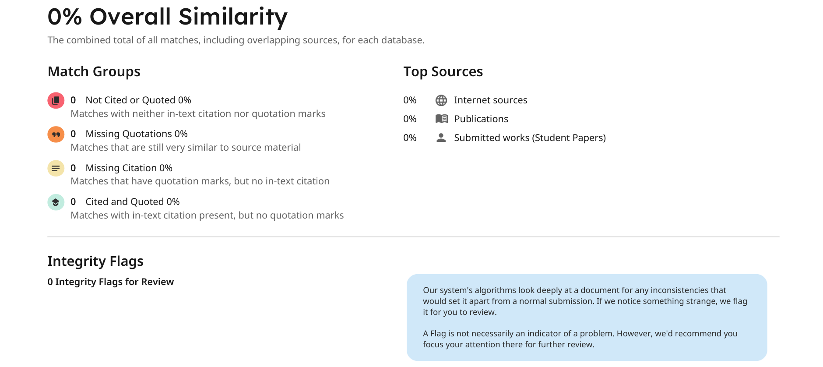

Figure 1 : Turnitin Similarity Report

Table of Contents

1 Introduction 3

1.1 Aims & Objective of Student 3

1.2 Aims & Objectives of Project 4

3 Wireframe 4

3.1 Types of Wireframes 4

4 Conclusion 6

5 References 7

# 1 Introduction

Java is a most popular object-oriented programming language developed in 1995 which is owned by Oracle. It is use for developing desktop and mobile application (GeeksforGeeks, 2025). In this project, we are using java to build gym management system which help gym management to handles attendance, payment, membership plan and many more easily & which enhance better user interface. We use java in this project because it has OOP (Object Oriented Programming) concept which allows implement real life object and many more. By using OOP it help to manage and maintain code in proper way so developer can add new features easily in future. Java is platform independent language so this project can be deployed in any OS (Operating System) (Spark Databox, 2023). Java has large community support, frameworks, libraries, so it is reliable for long term projects (Davis, 2022).

This system is designed in a way that gym management team can track customer details and store it in a computer file named gymMemberDetails.txt, which allows them to handle large data easily. We also focused on user interface side so that customer can interact easily with the system easily. Java supports OOP concept so we reused redundant code by using concept of encapsulation and methods to increase system performance. We wrote code in a way that new developer can understand it and update it because of different types of comment.

## 1.1 Aims & Objective of Student

1. To design and implement different concept of OOP principle to make system or program.
2. To know how different class works or connected with each other to make a system.
3. To know how to implement different built-in method or user defined methods in project.
4. To know how to use OOP principle to make code maintainable, reusable, readable etc.
5. To get learn how (GUI) Swing library works to make user friendly system.
6. To know how to store data in file by using concept of file handling & in array list.
7. To learn how to write industry standard code so it will help us in future when we write code for companies.
8. To know how to debug code.

## 1.2 Aims & Objectives of Project

1. To make better GUI so that user and gym management can use system easily.
2. To store members data safely in database and backup it if data get loss.
3. Customer can change or update their plan, details themselves.
4. To store data in file as well as array list to handle large amount of data easy.
5. To handle payment related data, and inform or remind customer and management if payment is due.

# 3 Wireframe

Wireframes is blueprints which help developer to make UI based on wireframe planning. It helps developer to where to align buttons, input fields, texts, etc. In simple term, wireframe is skeleton of app, website, system or other final product (Hannah, 2024). It helps to know client what type of product will be built in future so after final product is made there is no any problem to change developed product. It is most important step before developing a product because it saves time, money and other (Figma, n.d.).

## 3.1 Types of Wireframes

1. [Low Fidelity Wireframe](https://www.figma.com/community/file/1037703835411230636/Low-Fidelity-Wireframes)

[It](https://www.figma.com/community/file/1037703835411230636/Low-Fidelity-Wireframes) is basic wireframe technique or design in which shows only layout & skeleton only. It does not focus on color theme. It is easy to build and it mostly use black and white color (Figma, n.d.).

1. Mid Fidelity Wireframe

It is updated version of low fidelity wireframe which focuses on simple colors, size of components, buttons layout etc. It goes more deeper than low fidelity. It includes basic features but it doesn’t include animation & transition (Figma, n.d.).

1. High Fidelity Wireframe

It is a final sketch of any final product. It focuses on better user interface and experience, color theme, animation & transition etc. It is what a final product would be. So, client will know what product will be built. It includes final logo, fonts and other small details. It is more difficult to make than others wireframe and it is more costly (Figma, n.d.).

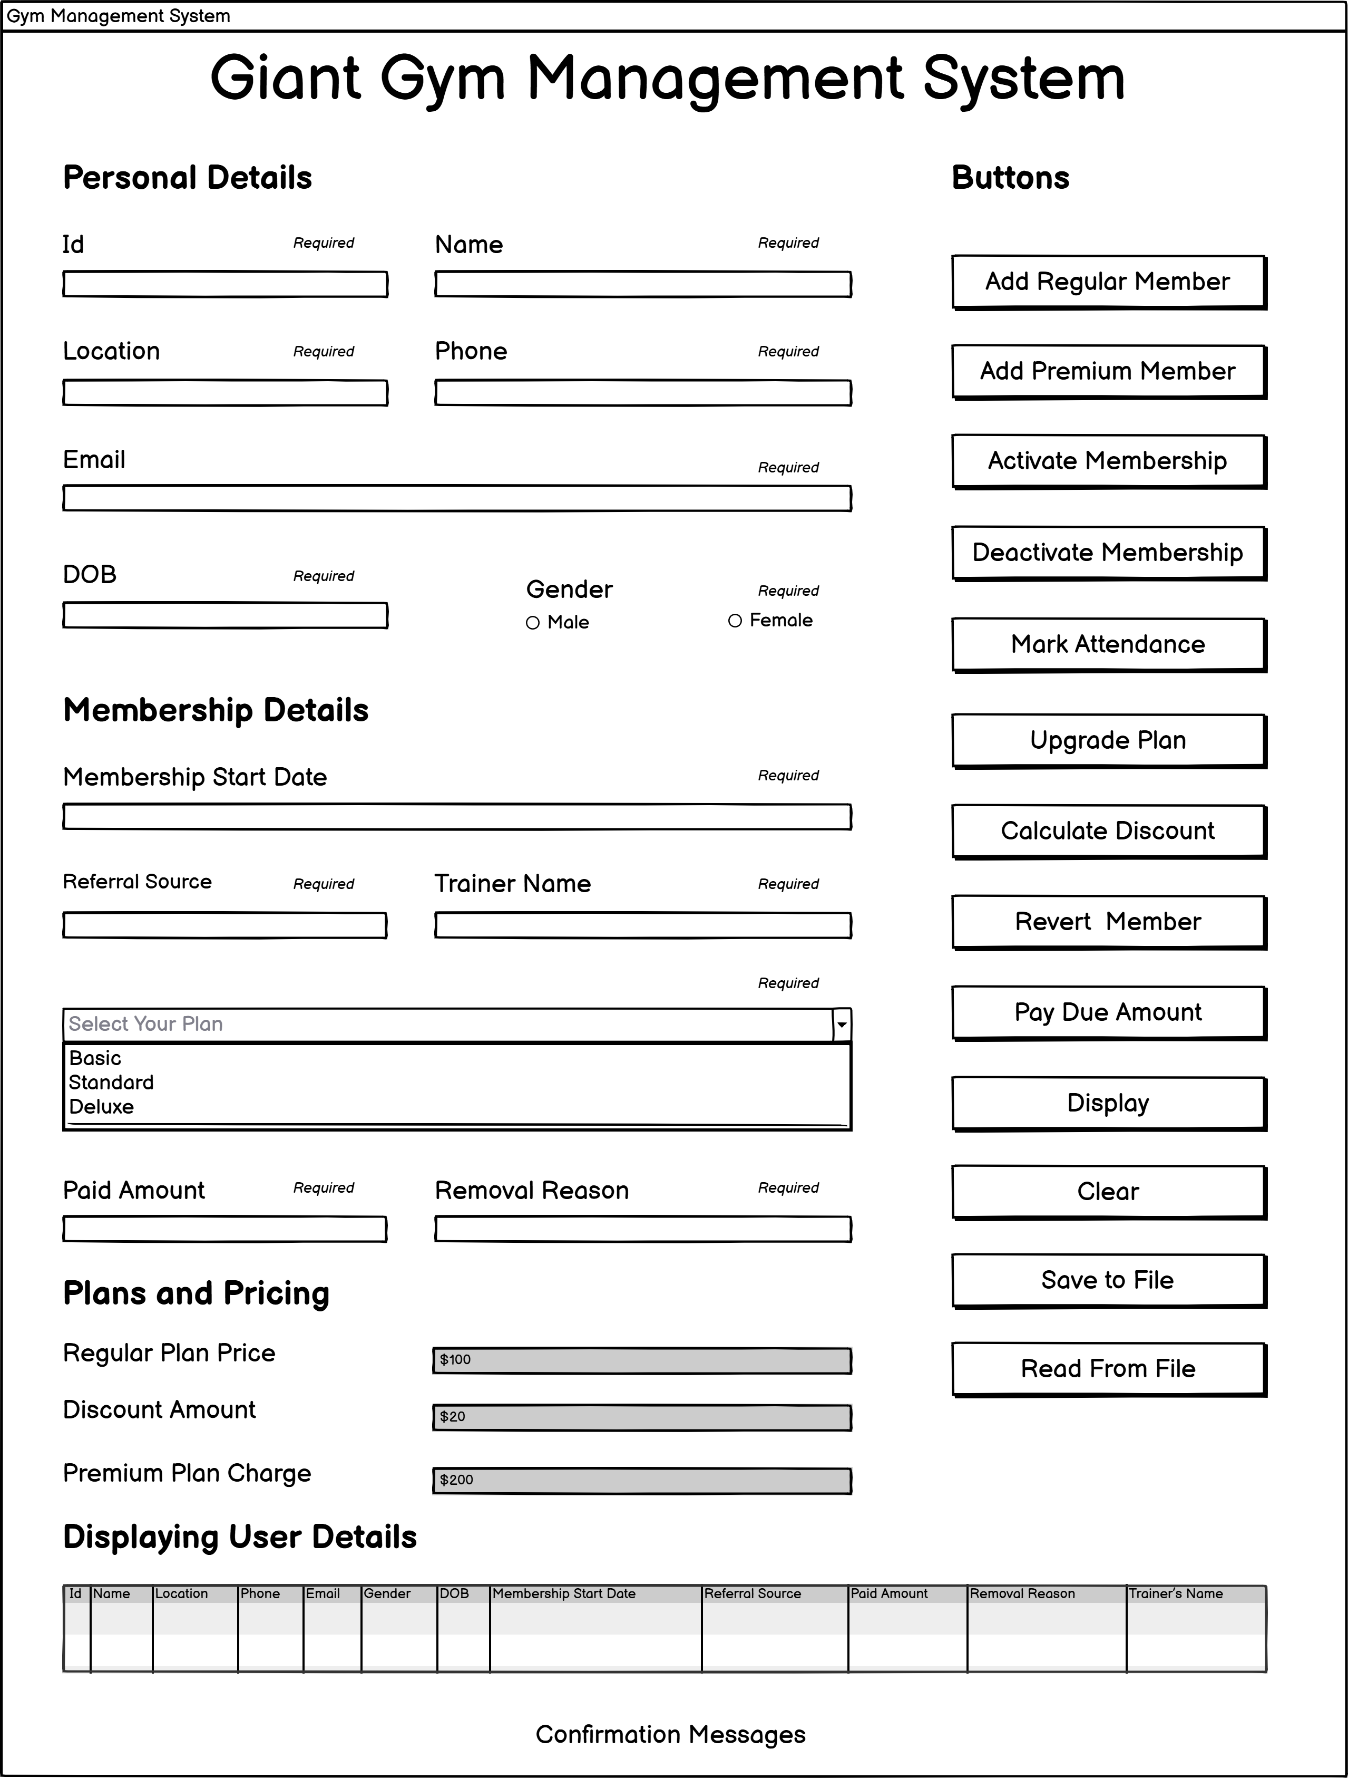

Figure 2 : Wireframe of Gym Management System

In the above image shows, wireframe or sketch of gym management system which we will build using java. We made this *low fidelity wireframe* using Balsamiq tool. We include different input fields like input text, radio buttons, button, dropdown etc. It is more user-friendly because we keep input field on left side and buttons on right side, which makes user to access features easily. We have divided different section like personal, membership, plan & pricing details, buttons so it will be easy to access.

# 4 Conclusion

Our coursework first milestone has been successfully completed which teaches a lot of things on java. This coursework focuses mainly on making multiple class and join together to make functional system, GUI, implementing OOP pillars which make code modular, maintainable & reusable. We made wireframe which makes visual idea how to make GUI using SWING library. It gives idea where to keep buttons and input fields, so it saves time & and no need to change layout in future.

By doing this coursework we make strong base or foundation on java and it will assist us to learn frameworks and library of java and language which follows OOP principle. Later we will add database to store user details and we will update more friendly UI in future.

# 5 References

1. Davis, R., 2022. *Advantage of Java.* [Online]   
   Available at: https://www.invensis.net/blog/benefits-of-java-over-other-programming-languages#:~:text=Being%20highly%20popular%20at%20enterprise,that%20has%20a%20JVM%20installed.  
   [Accessed 6 March 2025].
2. Figma, n.d.. *What is Wireframing?.* [Online]   
   Available at: https://www.figma.com/resource-library/what-is-wireframing/  
   [Accessed 6 March 2025].
3. GeeksforGeeks, 2025. *Introduction to Java.* [Online]   
   Available at: https://www.geeksforgeeks.org/introduction-to-java/  
   [Accessed 4 March 2025].
4. Hannah, J., 2024. *What is a Wireframe?.* [Online]   
   Available at: https://careerfoundry.com/en/blog/ux-design/what-is-a-wireframe-guide/  
   [Accessed 6 March 2025].
5. Spark Databox, 2023. *Why Java Platform Independent Language.* [Online]   
   Available at: https://sparkdatabox.com/blog/why-java-is-platform-independent/  
   [Accessed 4 March 2025].